ARTICLE TITLE
ABSTRACT
The abstract should be a single paragraph (150–250 words long) written in plain language and include a summary of the key conclusions of the manuscript. It should clearly state the purpose of the work, the scope of the effort, the procedures used to execute the work, and major findings. The abstract is the second most important online search discovery element, after the title. Authors should review the abstract to ensure that it accurately reflects the revised paper and should strive to include any applicable keywords that would likely be used during an online search. Mathematics and references are not permitted in the abstract and will be removed by the copyeditors. The author can use this template for reference or just use it for drafting your article and submit electronically for review only through the below link.
Keywords: Maximum of six keywords or phrases in alphabetical order separated by ‘,’.
https://shareit.joinjet.org/ojs/index.php/shareit/submission/wizard
- Introduction
Manuscripts must be submitted to the journal’s Submission page. Links to the submission page can be found on the SHAREit journal home page (shareit.joinjet.org/ojs), once the user creates an account, he/she can be able to submit his/her manuscript through a submission wizard. Any manuscript mailed or e-mailed will not be sent for review and will be returned to the author(s) with instructions for online submission.
  - Checklist for submission
The submission has not been previously published, nor is it before another journal for consideration (or an explanation has been provided in Comments to the Editor). When submitting a manuscript for an initial review, please ensure the following are completed before approving your PDF copy for submission. The manuscript should be in a 1.5 line-spaced, single-column format. The manuscript title and abstract are on the first page of your manuscript text, and it should not contain any form of text containing or revealing any of the author(s) information. However, a separate document entitled “Article Title Page.doc” available in the submission page under download section should be used for the same along with the acknowledgements (if any) for the technical (or) financial supports received during the work.
In Article Title Page all authors should give separate affiliation statements. The corresponding author should be noted with ’*’. An e-mail address is required for the corresponding author and encouraged for all authors.
- Guidelines for Paper Submission
As part of the submission process, authors are required to check off their submission's compliance with all of the following items, and submissions may be returned to authors that do not adhere to these guidelines.
- Initial submissions file is in Microsoft Word, LaTeX, or RTF document file format.
- Where available, URLs for the references have been provided.
- The text uses a 12-point font; employs italics, rather than underlining (except with URL addresses); and all illustrations, figures, and tables are placed within the text at the appropriate points, rather than at the end.
- All required submission questions must be answered.
- Funding for the research must be declared accurately via the Fund Ref tool provided in Editorial Manager.
- References or works cited are always included.
Authors are encouraged to have an ORCID and supply it with the submission. More information about ORCID can be found at their website.
  - Submission flow
The submission wizard contains five sections as shown in the Fig. 1.
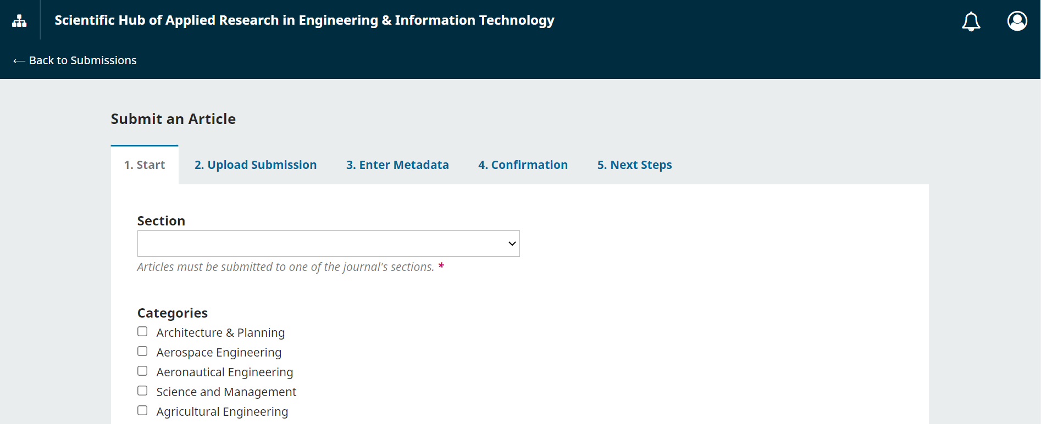
Fig. 1. Submission Flow
- Guidelines for drafting
  - General
The word “data” is plural, not singular. The subscript for the permeability of vacuum µ₀ is zero, not a lowercase letter “o.” The term for residual magnetization is “remanence”; the adjective is “remanent”; do not write “remnance” or “remnant.” Use the word “micrometer” instead of “micron.” A graph within a graph is an “inset,” not an “insert.” The word “alternatively” is preferred to the word “alternately” (unless you really mean something that alternates). Use the word “whereas” instead of “while” (unless you are referring to simultaneous events). Do not use the word “essentially” to mean “approximately” or “effectively.” Do not use the word “issue” as a euphemism for “problem.” When compositions are not specified, separate chemical symbols by en-dashes; for example, “NiMn” indicates the intermetallic compound Ni_{0.5}Mn_{0.5} whereas “Ni–Mn” indicates an alloy of some composition Ni_{x}Mn_{1-x}.
Be aware of the different meanings of the homophones “affect” (usually a verb) and “effect” (usually a noun), “complement” and “compliment,” “discreet” and “discrete,” “principal” (e.g., “principal investigator”) and “principle” (e.g., “principle of measurement”). Do not confuse “imply” and “infer.”
Prefixes such as “non,” “sub,” “micro,” “multi,” and “"ultra” are not independent words; they should be joined to the words they modify, usually without a hyphen. There is no period after the “et” in the Latin abbreviation “et al.” (it is also italicized). The abbreviation “i.e.,” means “that is,” and the abbreviation “e.g.,” means “for example” (these abbreviations are not italicized). An excellent style manual and source of information for science writers to citation is including the reference serial in square brackets as “[9]”.
  - Figures and Tables
Place figure captions below the figures; place table titles above the tables. If your figure has two parts, include the labels “(a)” and “(b)” as part of the artwork. Please verify that the figures and tables you mention in the text actually exist. Do not put borders around the outside of your figures. Use the abbreviation “Fig.” even at the beginning of a sentence. Do not abbreviate “Table.”, Figures and Tables are numbered with numerals [1,2,3].
Include a note with your final paper indicating that you request color printing. Do not use color unless it is necessary for the proper interpretation of your figures. Figure axis labels are often a source of confusion. Use words rather than symbols. As an example, write the quantity “Magnetization,” or “Magnetization M,” not just “M.” Put units in parentheses. Do not label axes only with units. As in Fig. 1, for example, write “Magnetization (A/m)” or “Magnetization (Am⁻¹),” not just “A/m.” Do not label axes with a ratio of quantities and units. For example, write “Temperature (K),” not “Temperature/K.” Multipliers can be especially confusing. Write “Magnetization (kA/m)” or “Magnetization (10³ A/m).” Do not write “Magnetization (A/m) × 1000” because the reader would not know whether the top axis label in Fig. 1 meant 16000 A/m or 0.016 A/m. Figure labels should be legible, approximately 8 to 12 point type.
Table1. The Arrangement of channels
Channels | Group 1 | Group 2 | … | Group c
Main channel | Channel 1 | Channel 2 | … | Channel c
Assistant channel | Channel 2 | Channel 3 | … | Channel 1

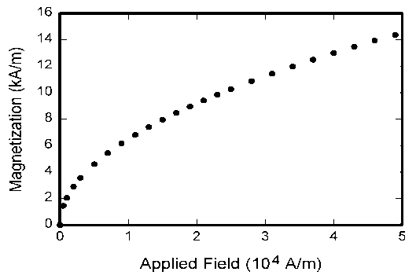
Fig. 2. Magnetization as a function of applied field.
  - Equations
Number equations consecutively with equation numbers in parentheses flush with the right margin, as in (1). First use the equation editor to create the equation. Then select the “Equation” markup style. Press the tab key and write the equation number in parentheses. To make your equations more compact, you may use the solidus ( / ), the exp function, or appropriate exponents. Use parentheses to avoid ambiguities in denominators. Punctuate equations when they are part of a sentence, as in
(1)
Be sure that the symbols in your equation have been defined before the equation appears or immediately following. Italicize symbols (T might refer to temperature, but T is the unit tesla). Refer to “(1),” not “Eq. (1)” or “equation (1),” except at the beginning of a sentence: “Equation (1) is ... .”
  - Abbreviations and Acronyms
Define abbreviations and acronyms the first time they are used in the text, even after they have already been defined in the abstract. Abbreviations such as SI, ac, and dc do not have to be defined. Abbreviations that incorporate periods should not have spaces: write “C.N.R.S.,” not “C. N. R. S.” Do not use abbreviations in the title unless they are unavoidable (for example, “Scientific Hub of Applied Research in Engineering & Information Technology” in the title of this article).
  - Other Recommendations
Use one space after periods and colons. Hyphenate complex modifiers: “zero-field-cooled magnetization.” Avoid dangling participles, such as, “Using (1), the potential was calculated.” [It is not clear who or what used (1).] Write instead, “The potential was calculated by using (1),” or “Using (1), we calculated the potential.”
Use a zero before decimal points: “0.25,” not “.25.” Use “cm³,” not “cc.” Indicate sample dimensions as “0.1 cm × 0.2 cm,” not “0.1 × 0.2 cm².” The abbreviation for “seconds” is “s,” not “sec.” Do not mix complete spellings and abbreviations of units: use “Wb/m²” or “webers per square meter,” not “webers/m².” When expressing a range of values, write “7 to 9” or “7-9,” not “7~9.”
A parenthetical statement at the end of a sentence is punctuated outside of the closing parenthesis (like this). (A parenthetical sentence is punctuated within the parentheses.) In American English, periods and commas are within quotation marks, like “this period.” Other punctuation is “outside”! Avoid contractions; for example, write “do not” instead of “don’t.” The serial comma is preferred: “A, B, and C” instead of “A, B and C.”
If you wish, you may write in the first person singular or plural and use the active voice (“I observed that ...” or “We observed that ...” instead of “It was observed that ...”). Remember to check spelling. If your native language is not English, please get a native English-speaking colleague to proofread your paper . Number citations consecutively in square brackets [1]. The sentence punctuation follows the brackets [2]. Multiple references [2], [3] are each numbered with separate brackets [1]–[3]. When citing a section in a book, please give the relevant page numbers [2]. In sentences, refer simply to the reference number, as in [3]. Please note that the references at the end of this document are in the preferred referencing style. Give all authors’ names; do not use “et al.” unless there are six authors or more. Use a space after authors' initials. Papers that have not been published should be cited as “unpublished” [4]. Papers that have been submitted for publication should be cited as “submitted for publication” [5]. Papers that have been accepted for publication, but not yet specified for an issue should be cited as “to be published” [6]. Please give affiliations and addresses for private communications [7].
Capitalize only the first word in a paper title, except for proper nouns and element symbols. For papers published in translation journals, please give the English citation first, followed by the original foreign-language citation [8].
- Review Criteria
Reviewer will perform the paper review based on the main criteria provided here. Please provide detailed public comments for each criterion.
- How this manuscript advances this field of research and/or contributes something new to the literature?
- Is the paper clearly written and well organized?
- Are all figures and tables appropriately provided and are their resolution good quality?
- Does the introduction state the objectives of the manuscript encouraging the reader to read on?
- Are the references relevant and complete? Supply missing references if any.
- Editorial Policy
The submitting author is responsible for obtaining agreement of all coauthors and any consent required from sponsors before submitting a paper. It is the obligation of the authors to cite relevant prior work. Authors of rejected papers may revise and resubmit them to the journal again.
- Publication Policy
The contents of the journal are peer-reviewed and archival. SHAREit- Scientific Hub of Applied Research in Engineering & Information Technology publishes scholarly articles of archival value as well as critical reviews and case studies of classical subjects and topics of current interest (https://shareit.joinjet.org/searchbyscope.html).
Authors should consider the following points:
- Technical papers submitted for publication must advance the state of knowledge and must cite relevant prior work.
- The length of a submitted paper should be commensurate with the importance, or appropriate to the complexity, of the work. For example, an obvious extension of previously published work might not be appropriate for publication or might be adequately treated in just a few pages.
- Authors must convince both peer reviewers and the editors of the scientific and technical merit of a paper; the standards of proof are higher when extraordinary or unexpected results are reported.
- Because replication is required for scientific progress, papers submitted for publication must provide sufficient information to allow readers to perform similar experiments or calculations and use the reported results. Although not everything need be disclosed, a paper must contain new, useable, and fully described information. For example, a specimen's chemical composition need not be reported if the main purpose of a paper is to introduce a new measurement technique. Authors should expect to be challenged by reviewers if the results are not supported by adequate data and critical details.
- Conclusion
The conclusion of a research paper is where you wrap up your ideas and leave the reader with a strong final impression. It has several key goals: a) Restate the research problem addressed in the paper, b) Summarize your overall arguments or findings, c) Suggest the key takeaways from your paper. The content of the conclusion varies depending on whether your paper presents the results of original empirical research or constructs an argument or review through engagement with a number of sources. A conclusion might elaborate on the importance of the work or suggest applications and extensions.
REFERENCES (A minimum of 15)
Periodical style
[1] S. Chen, B. Mulgrew, and P. M. Grant, “A clustering technique for digital communications channel equalization using radial basis function networks,” IEEE Trans. on Neural Networks, vol. 4, pp. 570-578, July 1993.
[2] J. U. Duncombe, “Infrared navigation—Part I: An assessment of feasibility,” IEEE Trans. Electron Devices, vol. ED-11, pp. 34-39, Jan. 1959.
[3] C. Y. Lin, M. Wu, J. A. Bloom, I. J. Cox, and M. Miller, “Rotation, scale, and translation resilient public watermarking for images,” IEEE Trans. Image Process., vol. 10, no. 5, pp. 767-782, May 2001.
Book style
[4] A. Cichocki and R. Unbehaven, Neural Networks for Optimization and Signal Processing, 1st ed. Chichester, U.K.: Wiley, 1993, ch. 2, pp. 45-47.
[5] W.K. Chen, Linear Networks and Systems, Belmont, CA: Wadsworth, 1993, pp. 123-135.
[6] H. Poor, An Introduction to Signal Detection and Estimation; New York: Springer-Verlag, 1985, ch. 4.
Book style with paper title and editor
[7] R. A. Scholtz, “The Spread Spectrum Concept,” in Multiple Access, N. Abramson, Ed. Piscataway, NJ: IEEE Press, 1993, ch. 3, pp. 121-123.
[8] G. O. Young, “Synthetic structure of industrial plastics,” in Plastics, 2nd ed. vol. 3, J. Peters, Ed. New York: McGraw-Hill, 1964, pp. 15-64.
Published Conference Proceedings style
[9] M. B. Kasmani, “A Socio-linguistic Study of Vowel Harmony in Persian (Different Age Groups Use of Vowel Harmony Perspective,” International Proceedings of Economics Development and Research, ed. Chen Dan, pp. 359-366, vol. 26, Singapore, 2011.
[10] W. D. Doyle, “Magnetization reversal in films with biaxial anisotropy,” in Proc. 1987 INTERMAG Conf., 1987, pp. 2.2-1-2.2-6.
Presented Conference Paper style
[11] G. W. Juette and L. E. Zeffanella, “Radio noise currents n short sections on bundle conductors,” presented at the IEEE Summer Power Meeting, Dallas, TX, June 22-27, 1990.
Thesis or Dissertation style
[12] J. Williams, “Narrow-band analyzer,” Ph.D. dissertation, Dept. Elect. Eng., Harvard Univ., Cambridge, MA, 1993.
[13] N. Kawasaki, “Parametric study of thermal and chemical nonequilibrium nozzle flow,” M.S. thesis, Dept. Electron. Eng., Osaka Univ., Osaka, Japan, 1993.
Patent style
[14] J. P. Wilkinson, “Nonlinear resonant circuit devices,” U.S. Patent 3 624 12, July 16, 1990.
Standards style
[15] Letter Symbols for Quantities, ANSI Standard Y10.5-1968.
Handbook style
[16] Transmission Systems for Communications, 3rd ed., Western Electric Co., Winston-Salem, NC, 1985, pp. 44-60.
[17] Motorola Semiconductor Data Manual, Motorola Semiconductor Products Inc., Phoenix, AZ, 1989.
Journal Online Sources style
[18] R. J. Vidmar. (August 1992). On the use of atmospheric plasmas as electromagnetic reflectors. IEEE Trans. Plasma Sci. [Online]. 21(3). pp. 876-880. Available: http://www.halcyon.com/pub/journals/21ps03-vidmar

